Jeric B | re:3D | GB3 Dial Indicator

**NOTE: THESE INSTRUCTIONS ARE FOR PERFORMING BED LEVELING WITH THE GB3 TROLLEY, NOT GB2**
- Unbox dial indicator (mm? in?)
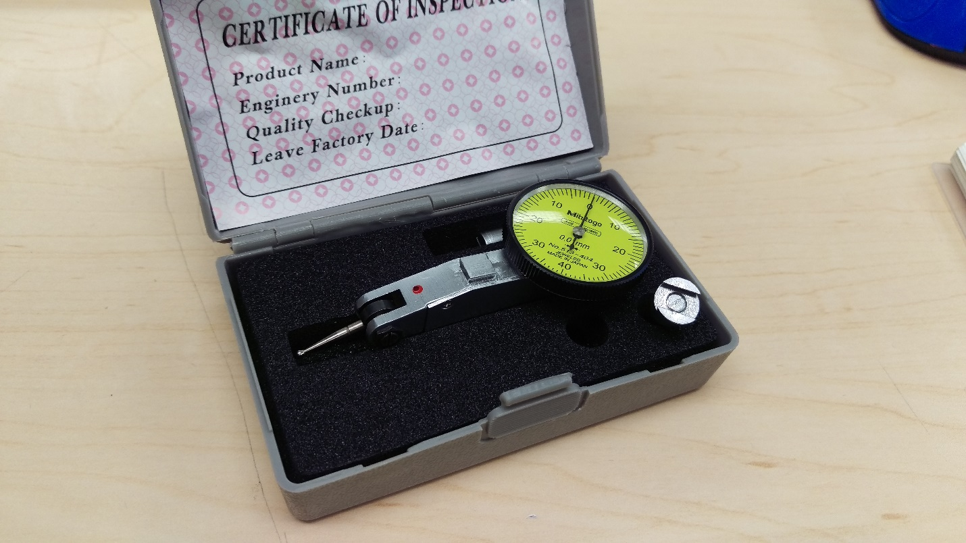
- Connect the smaller diameter shaft to the dovetail mount by threading it in
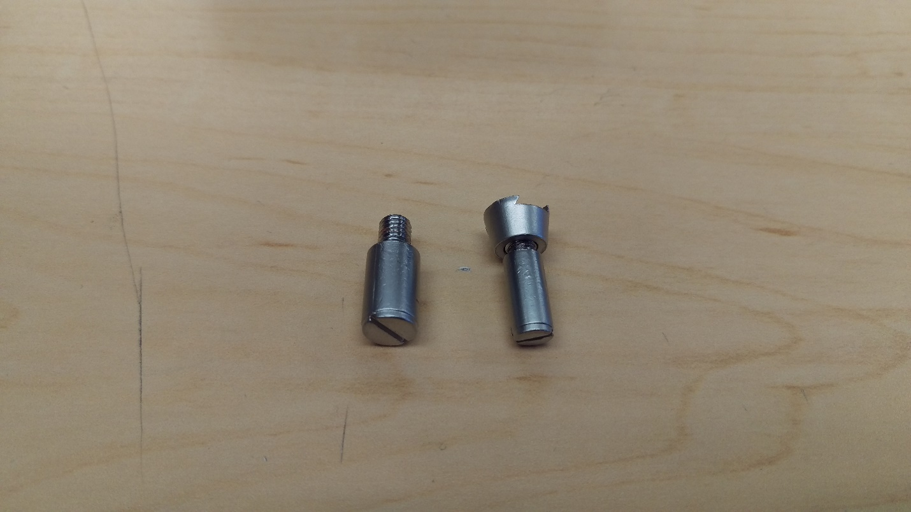
- Slide the dovetail mount onto the back of the dial indicator
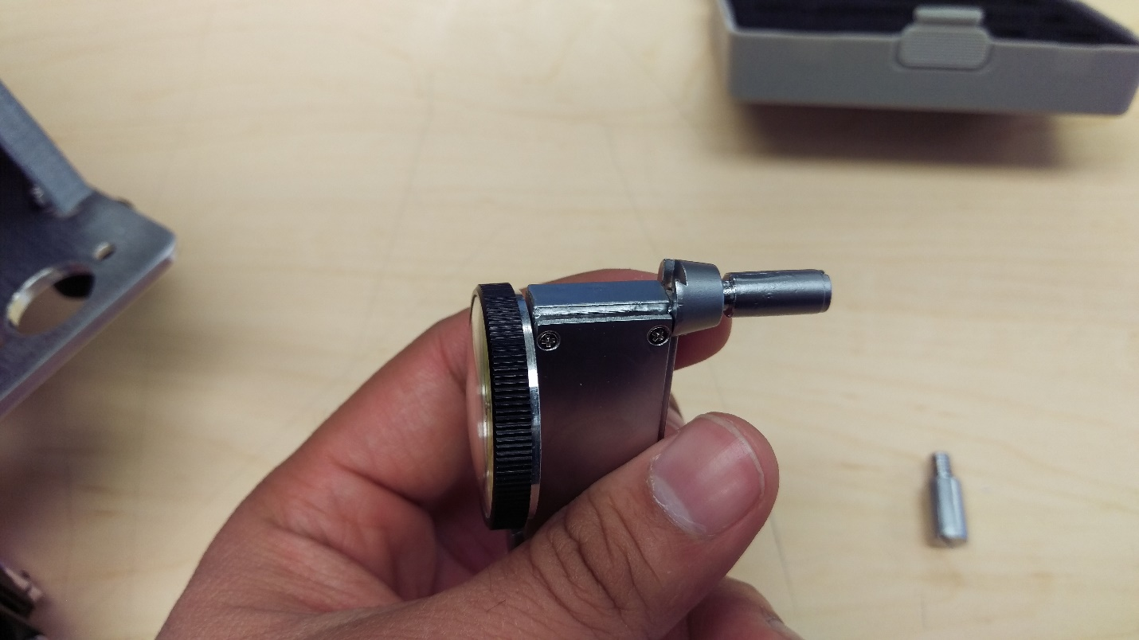
- Hand tighten the shaft to lock it into place
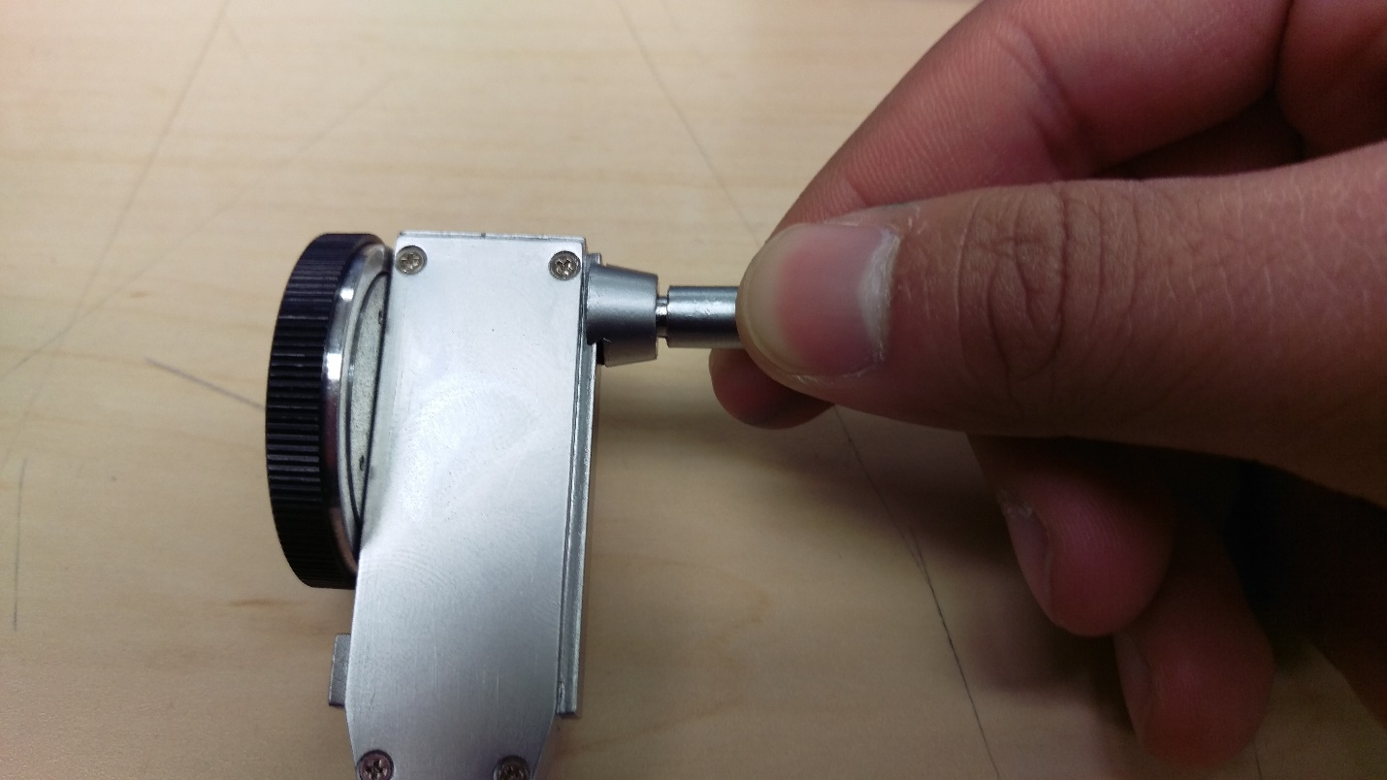
- Swivel the arm of the dial indicator so it is about 20 degrees away from the horizontal as shown
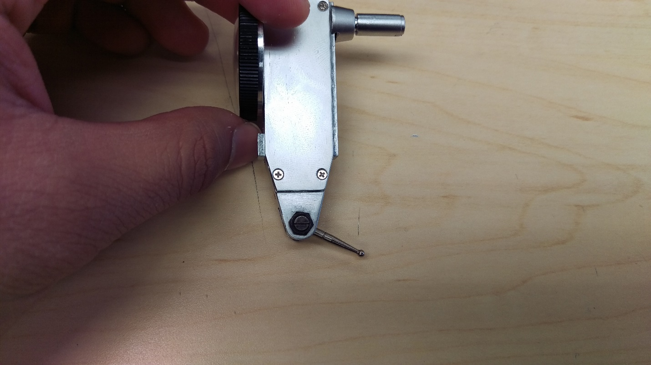
- Zero the dial indicator by holding the outer rim and rotating the face
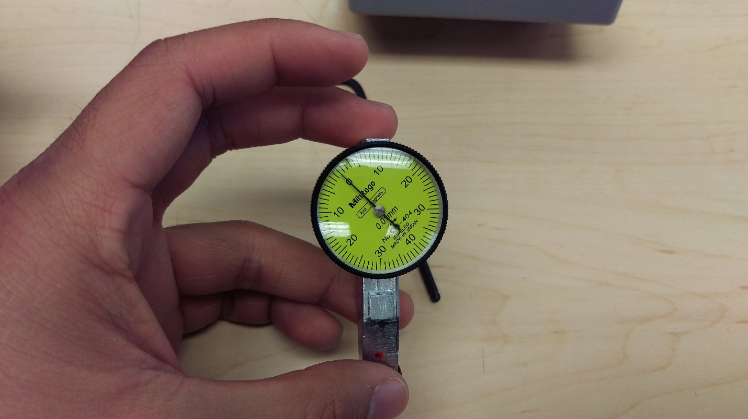
- Loosen the M3 SHCS set screw on the front of the extruder assembly with a 2.5mm Allen Key (shown on trolley separate from GB)
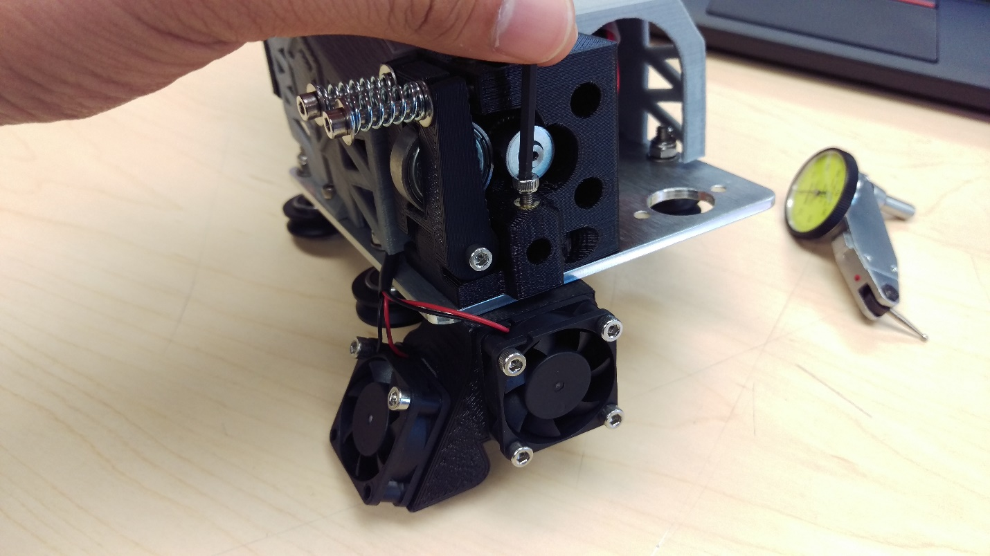
- Insert the shaft of the dial indicator into the cavity at the front of the extruder assembly
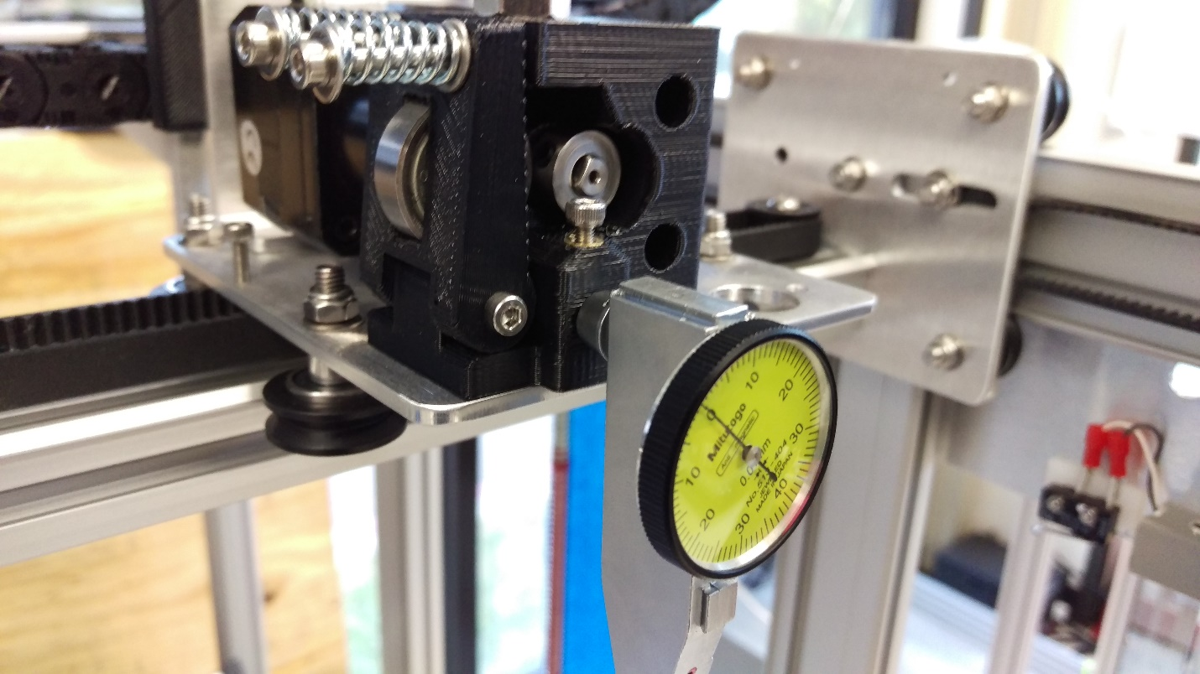
- Keeping the dial indicator as vertical as possible, lock it into place by tightening the M3 SHCS set screw with the 2.5 mm Allen Key
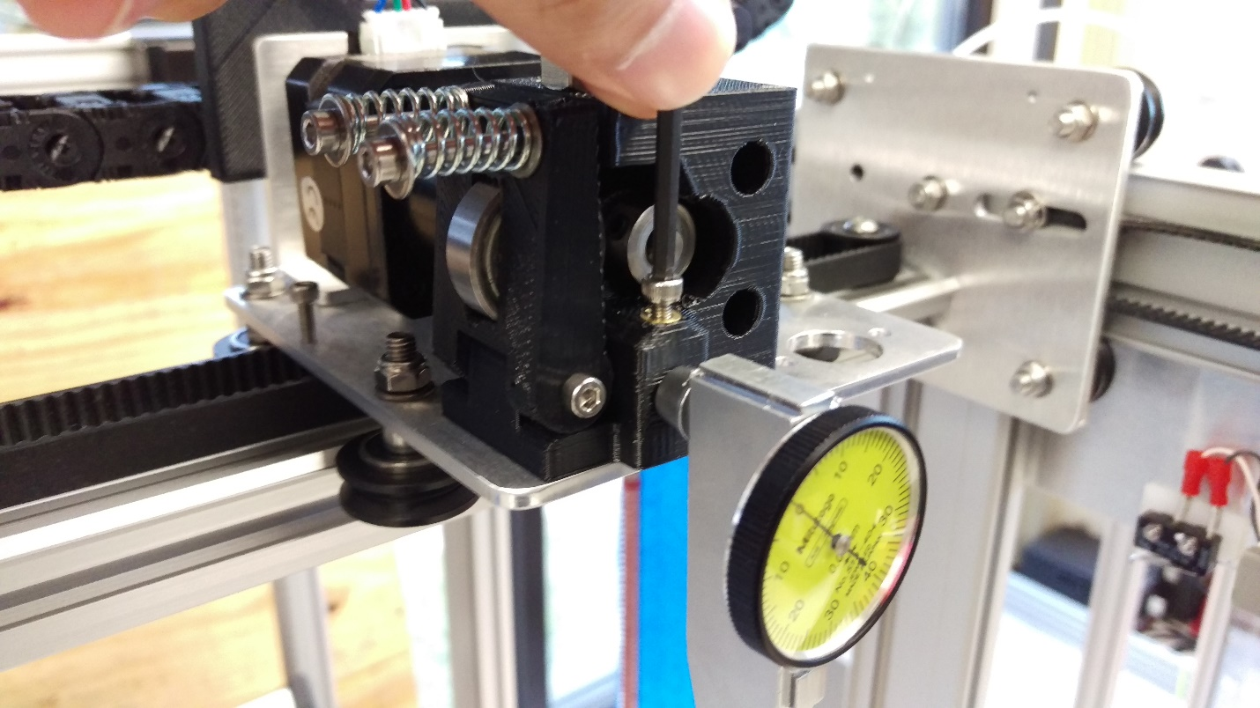
- (level with same directions as before—listed below for reference)
- Ensure dial indicator feeler arm is lower than the nozzle so that it contacts the bed surface before the nozzle
- Move the trolley to the center of the print area
- Slowly raise the bed until it makes contact with the dial indicator and moving the needle approx. 0.010 in/0.254 mm
- Zero again?
- Disable the motors to move the trolley freely by hand
- Use your hand to push the trolley plate and move the print head towards all four corners of the bed (AJ moves towards 4 leveling screws)
- Determine lowest corner (highest? According to AJ). Adjust bed leveling nut on underside of bed to pull the three other corners to about the same level
- Fine tune all around until all corners are within 0.010 in/0.254 mm
- When bed is level, tighten the M5x12 screws affixing bed side plates to bed support rails. Repeat for all four corners and verify the leveling hasn’t changed
- Remove dial indicator by loosening set screw. You may want to retighten the set screw after to make sure it doesn’t fall out
- Disassemble the dovetail mount from the dial indicator and place everything in the dial indicator case as before

