**Initial Tensile Testing for Natural PLA and Taulman Alloy 910**

July 16, 2015

Garrett Fish

Undergraduate Research Assistant

Mechanical Engineering, University of Texas at Austin

**Abstract**

An Investigation was conducted for the ultimate and yield strengths of the 3D printed parts of built with PLA, Taulman Alloy 910, and Taulman T-Glase at different infill percentages. These specimens were created using extrusion based additive manufacturing on the re3D Gigabot. The determination of these strengths will provide background information for early part design consideration by Gigabot users with these materials. Tensile data of the traditional ASTM type used here is insufficient to use as design specification, but does provide a partial look at the behavior of 3D geometric effects of using these constitutive plastics in an extrusion based printer. For this report, the results are presented, along with initial impressions from the results to help motivate strategy for more relevant testing strategies to aid machine parameter setting for desired properties with these materials. The primary parameter of variation is the fill fraction used internal to each specimen, which is varied from 0% to 100%. All samples have a common external sheath of 2 perimeters extruded using a .4mm nozzle diameter. The observed behavior will be compared to 100% fill specimens of the same material using the alternating 45 degree cross hatch fill pattern shared among all specimens .

**Introduction**

The fused deposition modeling (FDM) or extruded filament process is a manufacturing technique often used in 3D printing for rapid prototyping. The material is added one layer at a time by laying down thin filaments of material (plastic in this printer) in a soft/sticky form that cools and solidifies quickly, bonding as possible with adjacent filaments. One of the objectives of the Gigabot and other state of the art 3D printers is to print parts that withstand higher levels of stress and strain commensurate with the native filament material.

Because ASTM standards were created before the modernization of 3D printing some of the methods used in this investigation have specifications that deviate from the norm in order to produce data useful in the context of FDM created parts. ASTM still recommends D638 for tensile testing of FDM parts, but has not yet clearly articulated a standard under the conditions of partial fill that we are using here.

**Material Properties**

Testing specimens are made in the form of ASTM D638 Type I tensile bars.

The PLA (Polylactic Acid) plastic used in this test is Ingeo Biopolymer 4032D from NatureWorks[1]. It is advertised as having a tensile strength of 15 kpsi (103.4214 MPa) in the machine direction (X) and 21 kspi (144.7899 MPa) in the transverse direction (Y).

The Alloy 910 plastic used comes from the Taulman[2] company advertised as having a tensile stress when 3D printed of 8,100 PSI (55.8475 MPa).

The Taulman T-Glase alloy currently has no data published publically on the strength and strain capabilities of the material.

**Testing Methods**

Tensile specimens for Groups 1-12 and 18-22 of natural PLA and Taulman T-Glase respectively were tested on the Instron 3345 machine using an extension rate of 5 mm/min. The tensile force stopped when the measured load drops 40% from the peak value, indicating a rupture in the bar. The reported stress in this report is really a pseudo stress since it is composed in typical ASTM method of dividing the applied load by the original un-deformed cross sectional area of the specimen gauge section. It therefore takes no account of the amount of material in the gauge cross section as the % fill is varied. The strain is computed per ASTM methods by taking the extension and dividing by the gauge length of the un-deformed specimen.

The elastic modulus for the tensile bar is then calculated using the slope of a linear regression line run through the first ten points of the Stress vs. Strain graph for its testing. This elastic line is offset 2% in strain to find the appropriate yield point for the tested bar.

**Results and Discussion**

**Natural PLA:**

Figure 1 is sample of Stress vs Strain for the baseline PLA specimen data. This baseline is associated with a common 40% fill for parts fabricated on the Gigabot. All PLA specimens tested so far followed this pattern with fracture slightly beyond the ultimate strength with minimal necking.

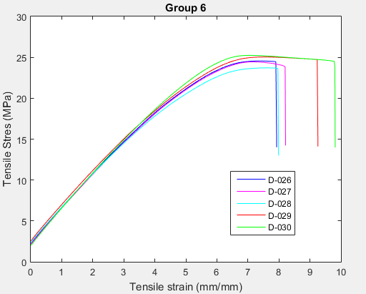

**Figure 1. Sample Stress vs. Strain curve for group 6 (40% infill)**

The ultimate stress and strain at break for groups 1-12 (natural PLA) at infill percentages incrementing by 10% from 0% are detailed below.

**Figure 2**

**Figure 3**

Figure 2 indicates that the ultimate tensile stress increases in a nearly linear fashion as the infill percentage increases over the range from 10% to 80%. Each 10% increment of infill percentage adds around 2.5 MPa of stress capacity in this region. Between 80% and 100% the improvement is greater than the previous trend, and the 0% fill falls below this middle trend. In Figure 3 the trend is less clear due to wider scatter in the results. We will examine this data further to obtain a numerical trend, but initial look appears to show an increasing strain at break with increasing % fill.

**Figure 4**

**Figure 5**

The yield stress and strain follow similar patterns to ultimate stress and strain at break. The uncertainty observed in the yield strain data (Figure 5) is approximately 1/2 the uncertainty observed in the strain at break data (Figure 3) for the PLA tested.

**Figure 6**

Because elastic modulus is based on stress over strain during the elastic period of the materials elongation, it makes sense that the pattern that it has with varying infill matches yield stress because yield strain varies little with change in % fill.

**Other Test Observations:**

PLA:

The fractures made in in the natural PLA tensile bars were brittle in nature and perpendicular to the pull direction. They do not show many signs of deformation beyond the snapping of the fibers vertically along the fracture as can be seen in Figure 7a,b.

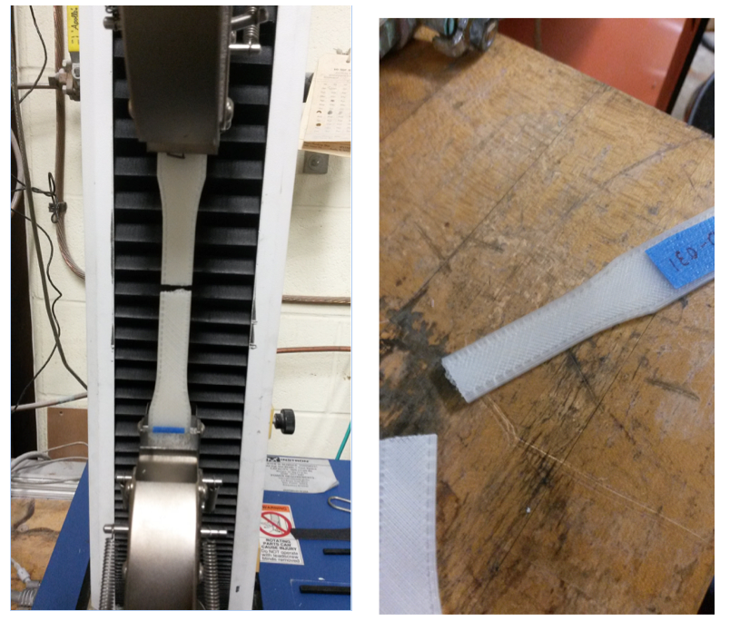

Figure 7a,b – PLA specimen fracture

**Taulman 910:**

The Taulman 910 specimens behaved much differently than the natural PLA after reaching their yield point during the elongation. The material has a very long strain hardening and necking period where it continues to elongate and deform before fracturing. With the extension rate used for PLA this resulted in tests taking 45 minutes and not always a fracture before the extension limit of the Instron was reached. Most applications will not see this form of slow loading, and before continuing with this material, some understanding of the strength dependency on the extension rate seemed warranted. Extension rates were increased incrementally in for groups of samples as indicated below:

|  |  |
| --- | --- |
| Serial # | mm/min |
| 61 | 5 |
| 62 | 5 |
| 63 | 20 |
| 64 | 10 |
| 65 | 50 |
| 66 | 50 |
| 67 | 50 |
| 68 | 50 |
| 69 | 100 |
| 70 | 200 |

Table 1 – Specimen # and extension rate variation for Taulman 910 initial testing

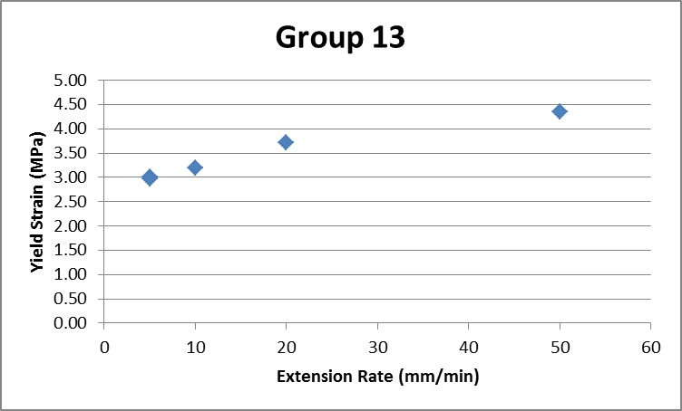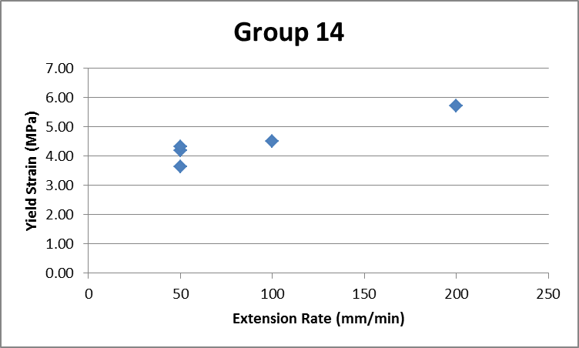

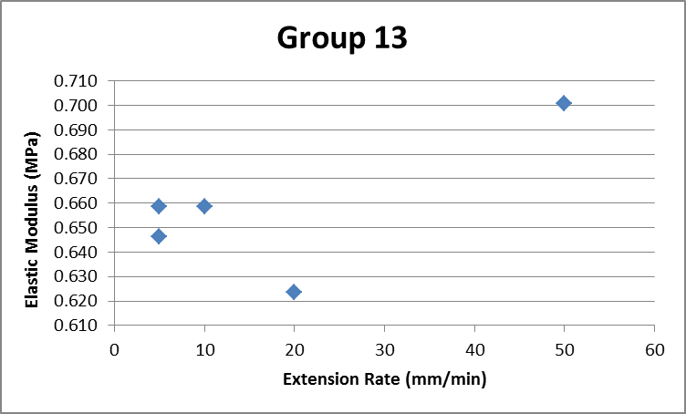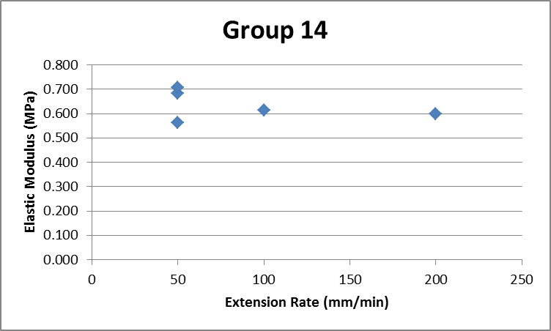

Figure 8 – Strain rate dependent results for Taulman 910

The graphs show that increasing the pull rate may result in a small increase in the yield strength but with the small sample size it is hard to evaluate the statistical significance of this observation. Elastic modulus does not appear to vary significantly vs extension rate. After this initial rate dependency was examined, all further tests used 200 mm/min extension rates and tests were completed in approximately 4 minutes. This creates a small inconsistency in the yield values with the first 2 groups but allowed for a method to be created for testing the remaining Taulman 910 specimens.

A typical set of stress vs strain measurement for the Taulman 910 is shown in Figure 9 all with 200 mm/min strain rate.

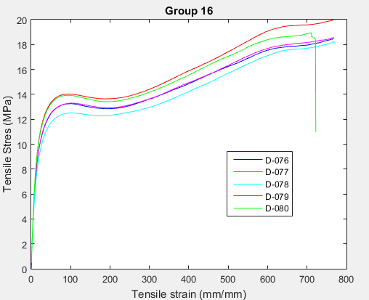

**Figure 9 - Sample Stress vs. Strain curve for group 16 (70% infill)**

As in the other stress graphs, as seen in Figure 9, Taulman 910 has an upward approximately linear trend. The strain however starts slightly lower and then levels out. It is possible that the lower values are outliers due to the inconsistent extension rate and wouldn’t show with more testing but regardless there were more low strain percentages with lower percent infill. Because both infill and strain were increasing with percent infill the elastic modulus tends to stay in place at first and then increase logarithmically at higher infill percentages.

**Figure 10**

**Figure 11**

**Figure 12**

Because many of the specimens did not fracture within the restricting bounds set on the machine only yield parameters could be tabulated for comparison. Note that fracture after such long extension, when it occurred resulted in a very large contraction in length as the load was released. Extension and contraction are illustrated in Figure 13 a and b respectively.

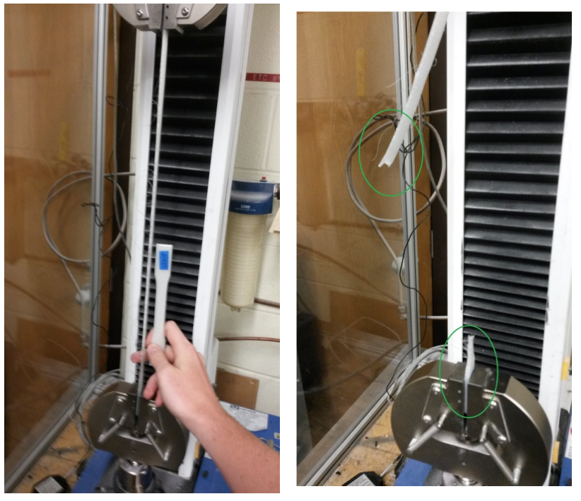

Figure

Figure 13 a,b – Taulman 910 extension (a) and recoil after fracture (b)

The Taulman 910 specimens also exhibited necking behavior which progressed up into the “ear” section of the samples and eventually would move under the grippers as shown in Figure 14. We did not observe loss of grip on the outer most portion of the sample, but continued extension would likely result in this loss given the strong poisson’s ratio contraction of lateral dimensions in the plastic necking process observed.

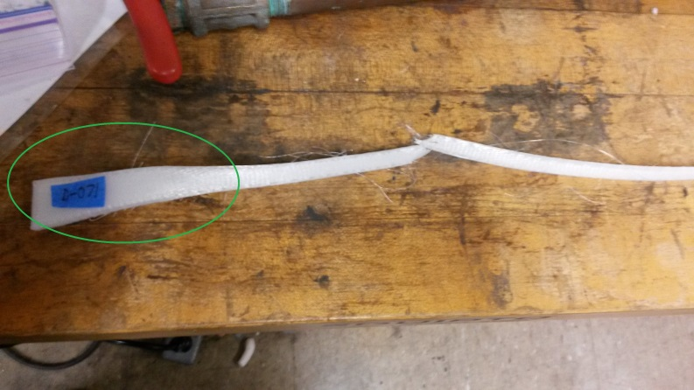

Figure 14 – Taulman 910 plastic deformation in the gripper section

**Taulman T-Glase:**

Specimens of Taulman T-Glase fractured in a more brittle fashion under a pull rate of 5 mm/min similar to the natural PLA specimens tested. When breaking, most tensile bars began to fracture along one side and quickly cut across the middle of the bar, but many times the outside layer of printed plastic would hold for a while longer with the stress greatly reduced. Below are graphs of stress and strain vs. infill at the yield point found using a 2% offset.

**Figure 15**

**Figure 16**

**Figure 17**

In a similar pattern to the PLA and Taulman 910 specimens the yield stress of Taulman T-Glase increased as infill percentage increased with the biggest changes in yield strain at higher infill.

Yield strain (figure 16) remained fairly consistent through the testing of different infill percentages and seemed only to vary randomly without correlation to the infill percentage. One cause for this may be that most of the load may be carried in the perimeter layers which are the same in all specimens, and increased filament bonding area compared with the interior regions. The ability of the material to stretch before fracturing may be primarily determined by the strength of the perimeter, regardless of its infill percentage. Elastic modulus (figures 17), like the strain shows higher infill percentages tend to increase by a higher margin on the increments above 50%.

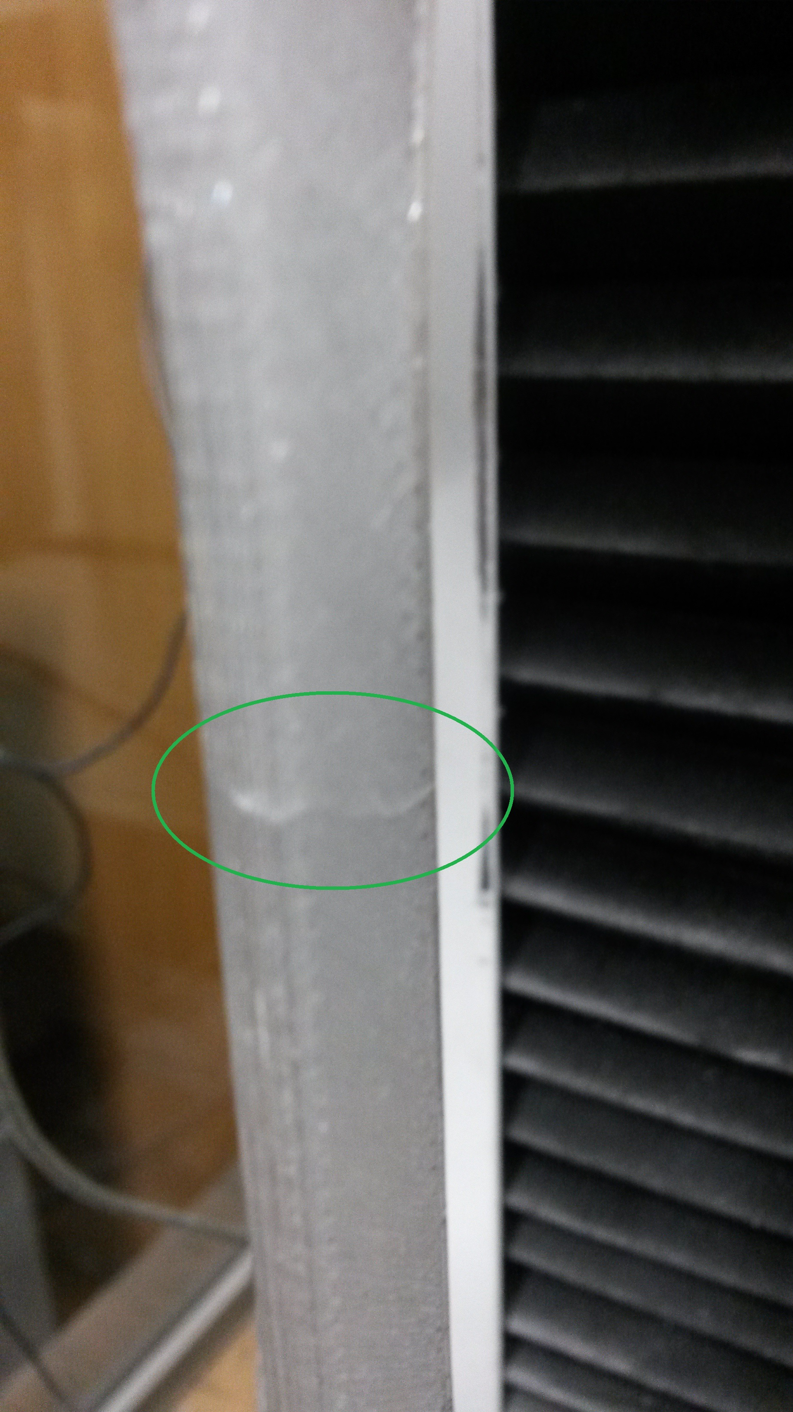

**Figure 18**

Figure 18 is a picture of specimen D-097 before the test and a crack looking deformation existed before any kind of stress was put on the part. This specimen fractured early and along the crack accounting for 1 of the two outliers on the summary graphs of Taulman T-Glase (50% infill).

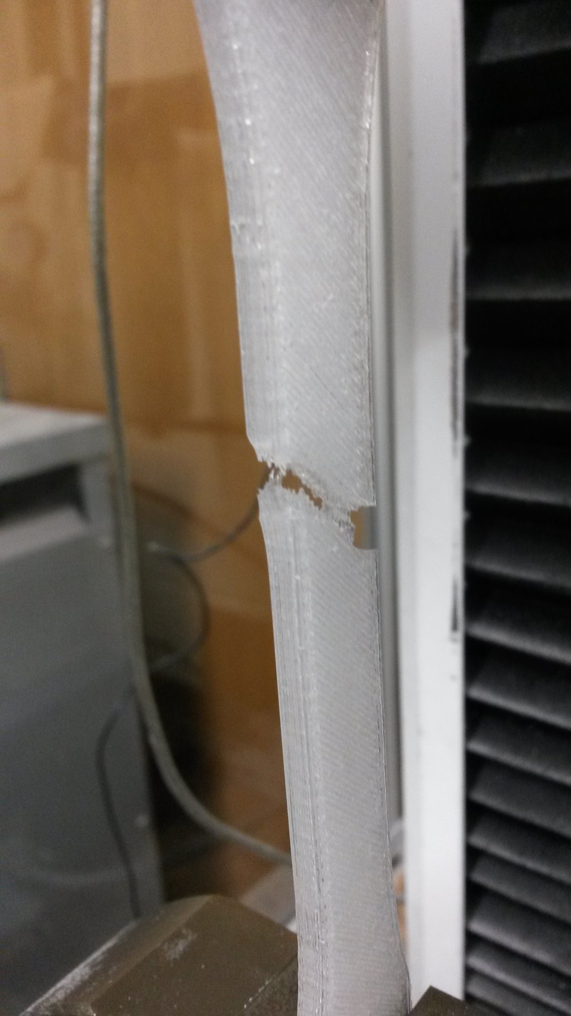

**Figure 19**

Figure 19 shows an common example of T-Glase specimen fracture. Note that the fracture would be diagonal along the internal fibers and fracture quickly except in cases like the one in the figure below.

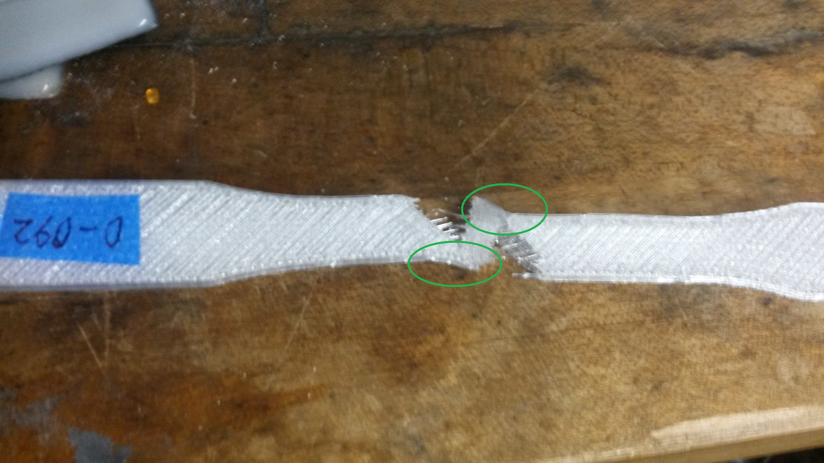

**Figure 20 – Edge Strength of build holding after break**

In the Figure 20 above the green circles highlight the edges of the 3-D build that are stronger due to their orientation that runs along the same axis as the stress exerted on the tensile bar. This suggests that the perimeter, aligned in the direction of the applied force is stronger than the hatch pattern filling and will sometimes endure the initial fracturing and still be holding together after the load has been greatly reduced. The specimen is stretched to a “yield” point which may be associated with bond breakage internal to the specimen and prior to the overall fracture of the specimen. About 2/5 of the specimens would break leaving behind small pieces on the edge so the stress did not drop instantly. The graphs for these specimens go on much longer and decline slowly after an initial large drop in stress.

**Summary**

A series of ASTM D638 modeled tensile tests were carried out on two materials, a PLA and a highly extensible Alloy 910 from Taulman to gain information on the variation in as printed properties as a function of the % fill if the interior of the specimens. The fracture and yield stress properties generally followed a linear relationship for % fill between 10-80%. A weakening effect for 0% cases in both materials is observed likely due to instability of the outer shell without any infill. These 0 and 10% specimens are likely also being non-uniformly gripped in the test machine, and for future testing some consideration should be given to printing the non-gauge section with at least 80% fill. The 80-100% fill specimens showed a higher stress trend than the lower % fill trend, and this might also be enhanced by geometric strengthening through increased bond area between fill filaments and between these filaments and the outer shell forms a more stable geometry in the core of the samples.

The PLA strain to break data shows only slight influence of % fill with the values generally in the range of 8% +/- 2%. Because breakage was infrequent and inconsistent in the highly elongated Taulman 910 our focus was on yield properties. The stress trends were similar to that of PLA magnitudes of roughly 1/3 that of PLA. Taulman 910 yield strain (2% offset method) were consistently 8% with infill percentages greater than 40. It’s yield strain fell to ~7% for infill of only 10%.

We would like to compare this data to something representing a “strongest practical print” and are suggesting for both materials that samples be built which have the fill 100% and all oriented along the tensile axis. This will allow a design knock down factor that could be developed as a function of both fill % and later fill pattern geometry if desired.

**Appendix A (PLA) - % Fill Variation Results**

0%

20%

20%

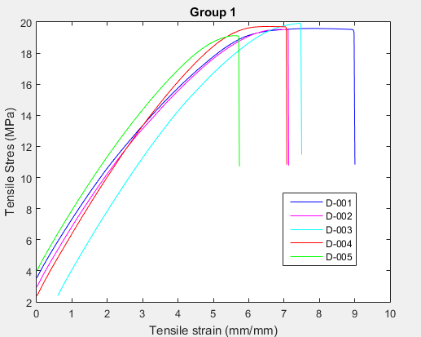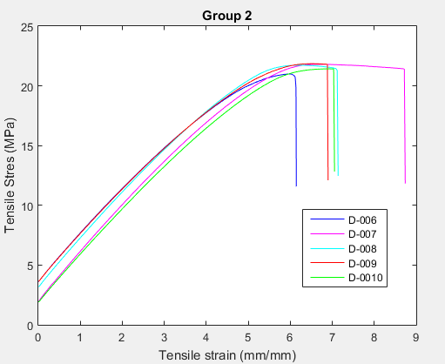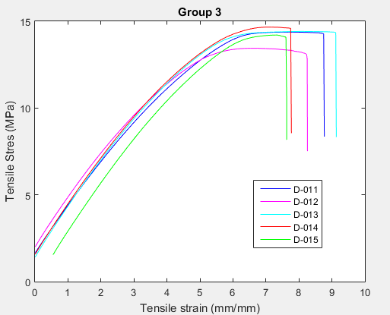

40%

30%

10%

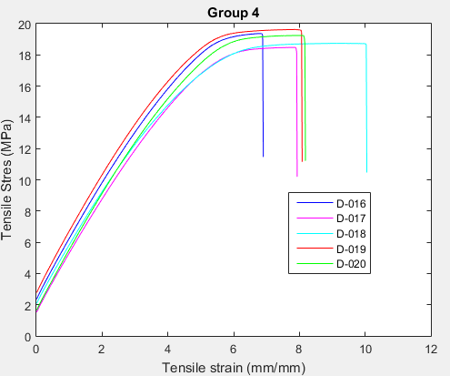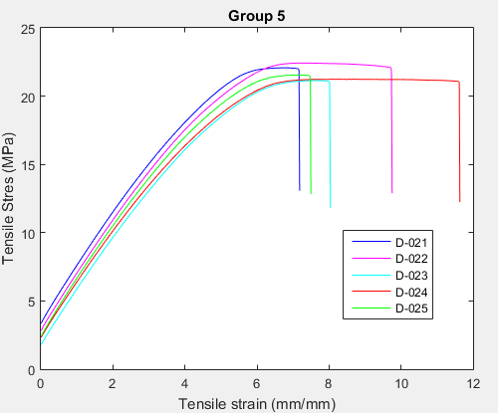

70%

60%

50%

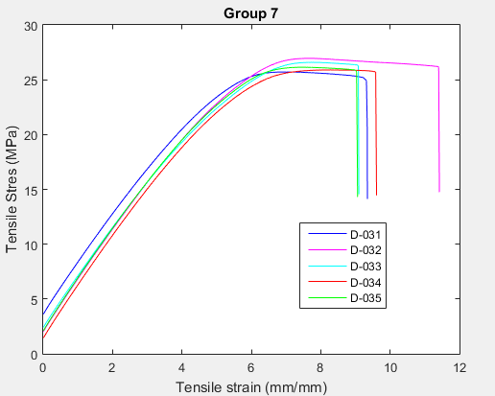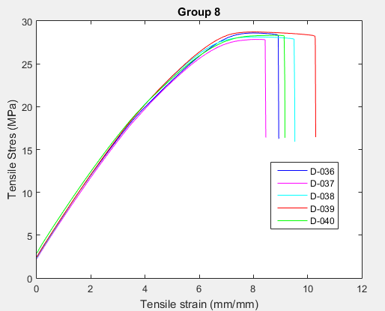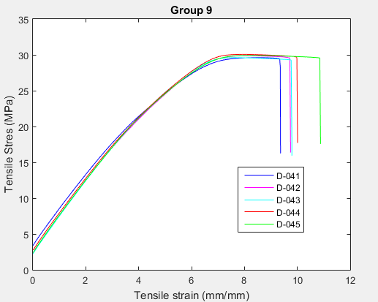

100%

80%

90%

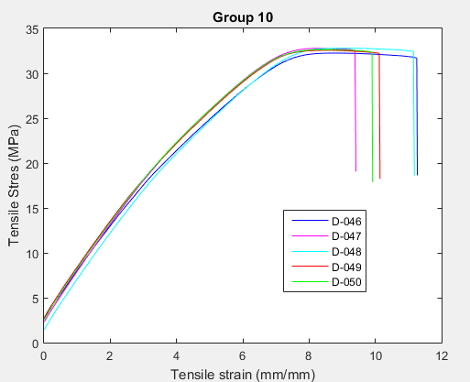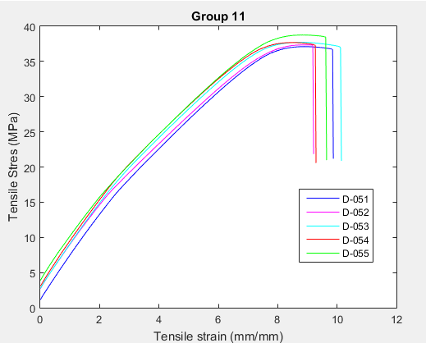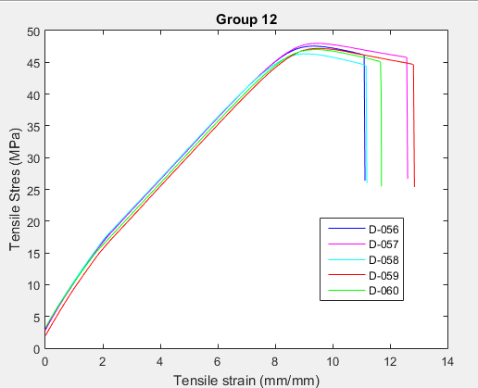

**Appendix B (Taulman 910)**

50%

30%

10%

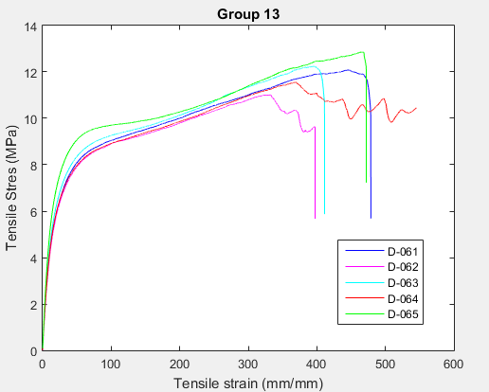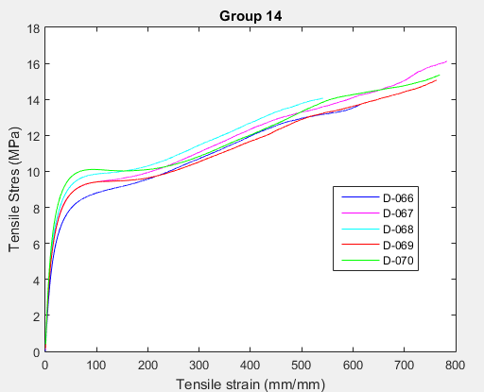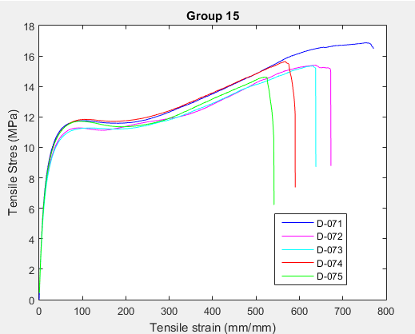

90%

70%

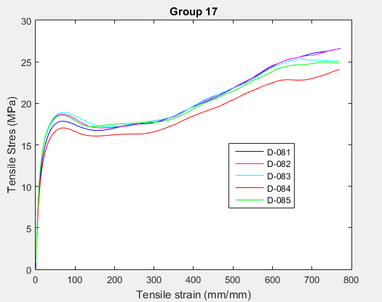

**Appendix C (Taulman T-Glase)**

**Group 18 - 10 % fill Group 19 30% fill**

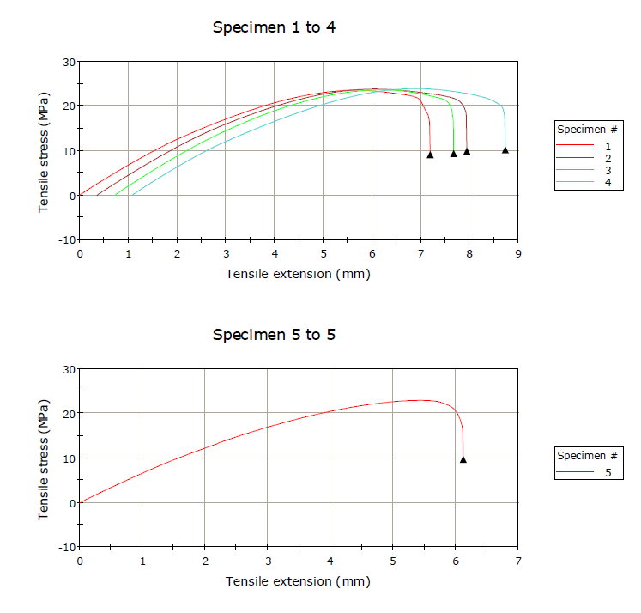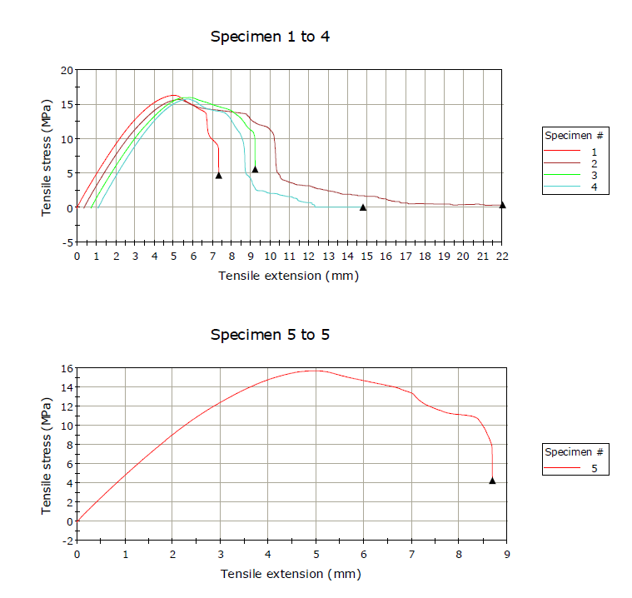

**Group 20 50% fill Group 21 70% fill**

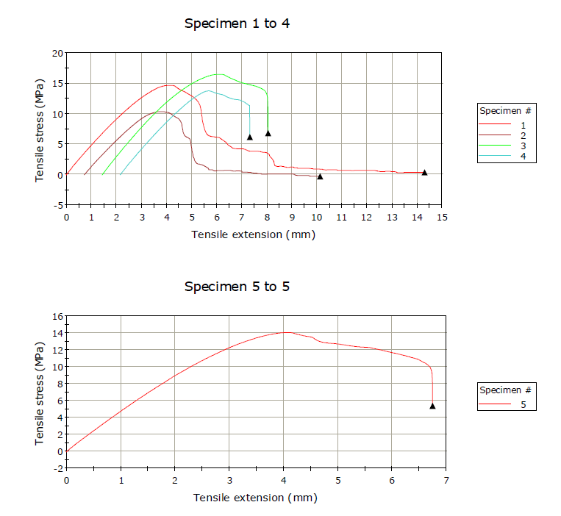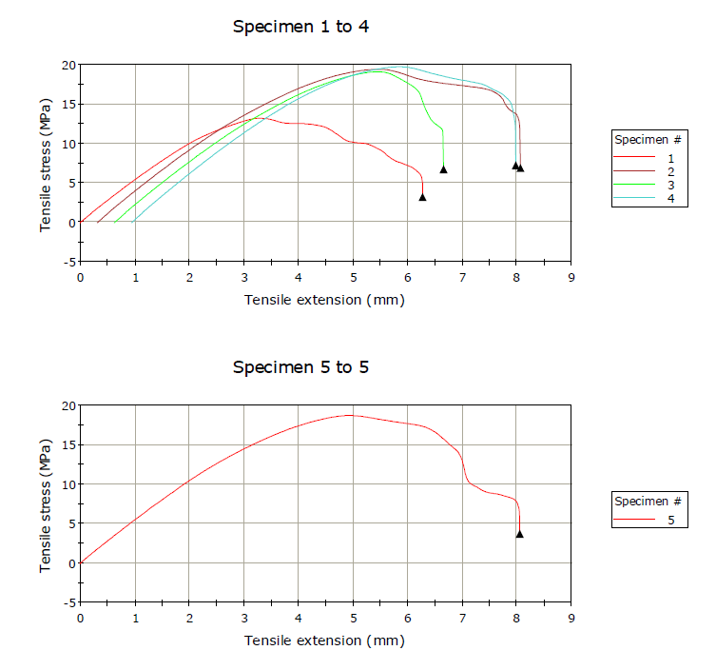

**Group 22 90% fill**

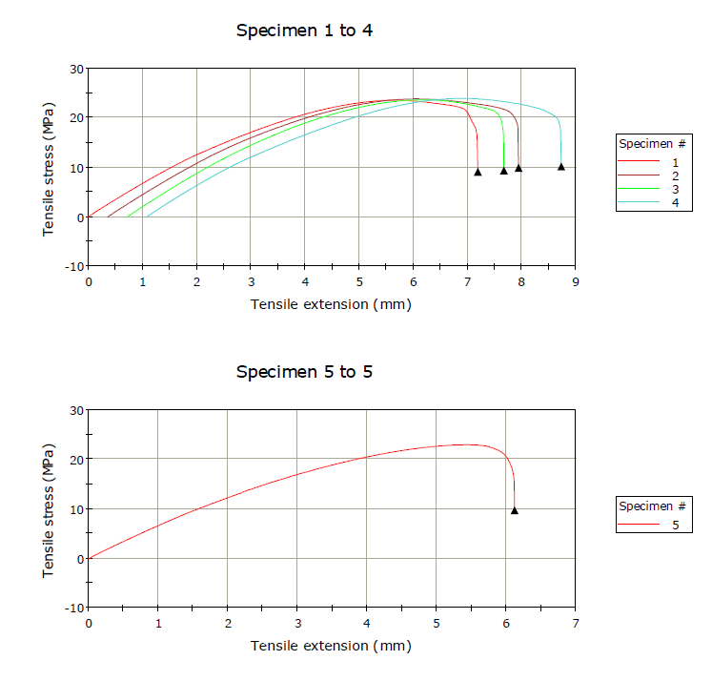

1. http://www.natureworksllc.com/
2. http://www.taulman3d.com/